95% CI’s for Gamma (age at which mortality hazard first reaches 2/3)
and M (maximum age at death)
 | Male |  |  |  | Female
 | Gamma |  | M |  | Gamma |  | M
Cohort | Lower 95% CI | Upper 95% CI | Lower 95% CI | Upper 95% CI | Lower 95% CI | Upper 95% CI | Lower 95% CI | Upper 95% CI
1880 | 100.4 | 101.3 | 102.5 | 109.9 | 103.0 | 104.3 | 105.8 | 113.3
1890 | 101.5 | 102.4 | 103.7 | 111.2 | 104.5 | 105.8 | 107.5 | 115.1
1900 | 103.0 | 103.9 | 104.8 | 112.3 | 105.5 | 106.8 | 108.7 | 116.2
1910 | 104.7 | 105.6 | 106.9 | 114.4 | 106.4 | 107.6 | 110.2 | 117.7
1920 | 107.2 | 108.1 | 109.5 | 117.1 | 107.9 | 109.3 | 112.2 | 119.7
1930 | 112.9 | 114.3 | 115.1 | 122.7 | 112.6 | 114.3 | 116.6 | 124.3
1940 | 118.5 | 121.1 | 121.0 | 128.7 | 116.9 | 119.3 | 121.0 | 128.8
1950 | 121.2 | 125.4 | 124.7 | 132.9 | 117.3 | 121.1 | 122.8 | 130.9
1960 | 121.4 | 129.5 | 125.8 | 135.9 | 117.7 | 124.3 | 124.1 | 133.2
1970 | 121.2 | 132.5 | 126.0 | 138.1 | 118.6 | 126.7 | 125.0 | 135.1
95% CI’s for the change in remaining life expectancy at age 50
relative to cohort born 10 years earlier (years)
 | Due to postponement |  |  |  |  |  | Due to compression
 | Male |  |  | Female |  |  | Male |  |  | Female
Cohort | Lower 95% CI | Median | Upper 95% CI | Lower 95% CI | Median | Upper 95% CI | Lower 95% CI | Median | Upper 95% CI | Lower 95% CI | Median | Upper 95% CI
1880 | -0.2 | 0.0 | 0.2 | 0.6 | 0.4 | 1.1 | -0.4 | -0.1 | 0.3 | 0.1 | 0.5 | 0.9
1890 | 0.1 | 0.3 | 0.4 | 0.8 | 0.5 | 1.1 | -0.3 | -0.0 | 0.2 | 0.2 | 0.5 | 0.8
1900 | 0.2 | 0.4 | 0.5 | 1.0 | 0.3 | 1.3 | -0.5 | -0.2 | 0.1 | 0.5 | 0.8 | 1.1
1910 | 1.1 | 0.4 | 1.4 | 1.5 | 0.3 | 1.8 | 0.6 | 0.9 | 1.1 | 1.1 | 1.4 | 1.7
1920 | 1.9 | 0.7 | 2.2 | 1.5 | 0.6 | 1.9 | 1.1 | 1.4 | 1.7 | 0.8 | 1.1 | 1.4
1930 | 3.2 | 1.8 | 3.7 | 2.8 | 1.8 | 3.2 | 1.4 | 1.7 | 2.0 | 0.9 | 1.1 | 1.4
1940 | 4.2 | 2.0 | 5.1 | 2.9 | 1.9 | 3.8 | 2.3 | 2.6 | 2.9 | 1.2 | 1.5 | 1.8
1950 | 2.2 | 1.2 | 3.8 | 1.1 | 0.5 | 2.6 | 1.4 | 1.8 | 2.1 | 1.1 | 1.4 | 1.8
1960 | 0.1 | 0.8 | 2.8 | 0.2 | 0.7 | 2.4 | 0.2 | 0.6 | 1.0 | 0.2 | 0.6 | 0.9
1970 | -0.1 | 0.4 | 2.3 | 0.2 | 0.7 | 2.3 | -0.0 | 0.7 | 1.3 | -0.1 | 0.5 | 1.1
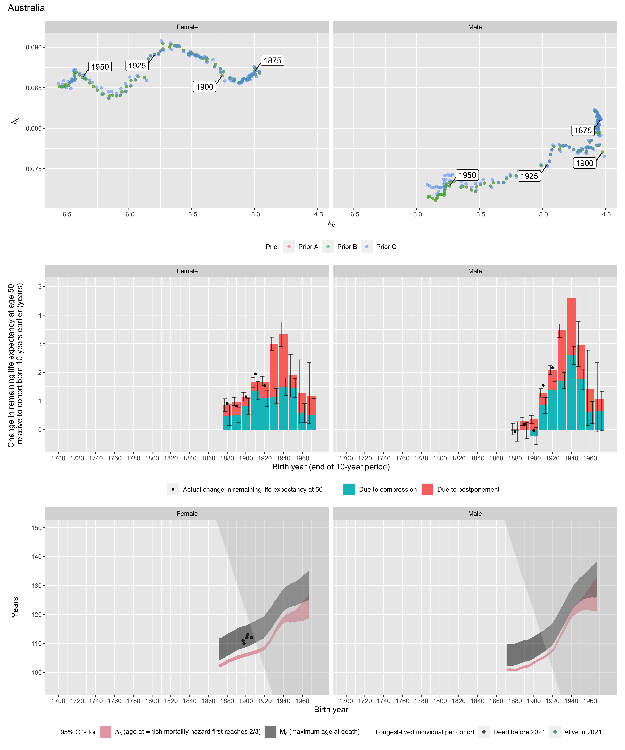
Longest-lived person in each cohort
Sex | Age | Cohort | Alive | Name | Birth date | Death date | Source
Female | 111 | 1897 | N | Myrtle Jones | 1897-04-18 | 2009-01-12 | GRG
Female | 110 | 1898 | N | Doreen Washington | 1898-05-24 | 2009-02-04 | GRG
Female | 112 | 1901 | N | Jane Gray | 1901-12-01 | 2014-06-07 | GRG
Female | 113 | 1902 | N | Ethel Farrell | 1902-11-27 | 2015-12-20 | GRG
Female | 112 | 1906 | N | Margaret Vivian | 1906-02-25 | 2018-09-20 | GRG

