95% CI’s for Gamma (age at which mortality hazard first reaches 2/3)
and M (maximum age at death)
 | Male |  |  |  | Female
 | Gamma |  | M |  | Gamma |  | M
Cohort | Lower 95% CI | Upper 95% CI | Lower 95% CI | Upper 95% CI | Lower 95% CI | Upper 95% CI | Lower 95% CI | Upper 95% CI
1900 | 104.1 | 105.1 | 109.0 | 116.5 | 106.6 | 109.0 | 112.6 | 120.3
1910 | 105.6 | 106.5 | 111.2 | 118.7 | 109.0 | 111.5 | 115.9 | 123.6
1920 | 105.6 | 106.5 | 112.1 | 119.6 | 109.6 | 111.9 | 117.6 | 125.3
1930 | 109.0 | 110.0 | 115.7 | 123.2 | 112.5 | 115.0 | 121.0 | 128.8
1940 | 112.1 | 113.4 | 118.9 | 126.5 | 116.6 | 119.7 | 125.0 | 132.9
1950 | 115.8 | 117.5 | 122.8 | 130.4 | 120.1 | 123.8 | 128.8 | 137.0
1960 | 116.9 | 119.0 | 123.9 | 131.5 | 125.0 | 130.9 | 132.9 | 141.8
1970 | 117.4 | 120.1 | 125.1 | 132.9 | 128.5 | 136.5 | 136.6 | 146.6
95% CI’s for the change in remaining life expectancy at age 50
relative to cohort born 10 years earlier (years)
 | Due to postponement |  |  |  |  |  | Due to compression
 | Male |  |  | Female |  |  | Male |  |  | Female
Cohort | Lower 95% CI | Median | Upper 95% CI | Lower 95% CI | Median | Upper 95% CI | Lower 95% CI | Median | Upper 95% CI | Lower 95% CI | Median | Upper 95% CI
1900 | 0.8 | 0.0 | 1.0 | 1.0 | 0.2 | 1.3 | 0.7 | 0.8 | 1.0 | 0.7 | 0.9 | 1.2
1910 | 2.3 | 0.4 | 2.4 | 3.2 | 0.8 | 3.4 | 1.8 | 2.0 | 2.1 | 2.2 | 2.5 | 2.7
1920 | 2.4 | 0.0 | 2.5 | 2.9 | 0.2 | 3.2 | 2.3 | 2.4 | 2.6 | 2.6 | 2.8 | 3.0
1930 | 1.1 | 1.1 | 1.3 | 2.5 | 1.2 | 2.9 | -0.1 | 0.1 | 0.2 | 1.3 | 1.5 | 1.7
1940 | 2.6 | 1.1 | 2.9 | 2.6 | 1.9 | 3.3 | 1.5 | 1.6 | 1.8 | 0.8 | 1.0 | 1.3
1950 | 1.7 | 1.4 | 2.1 | 1.7 | 1.7 | 2.8 | 0.4 | 0.5 | 0.7 | 0.4 | 0.6 | 0.8
1960 | 1.9 | 0.5 | 2.6 | 2.4 | 2.5 | 4.3 | 1.6 | 1.8 | 1.9 | 0.5 | 0.8 | 1.1
1970 | 1.3 | 0.3 | 2.1 | 2.2 | 2.0 | 4.5 | 1.1 | 1.4 | 1.8 | 0.8 | 1.3 | 1.7
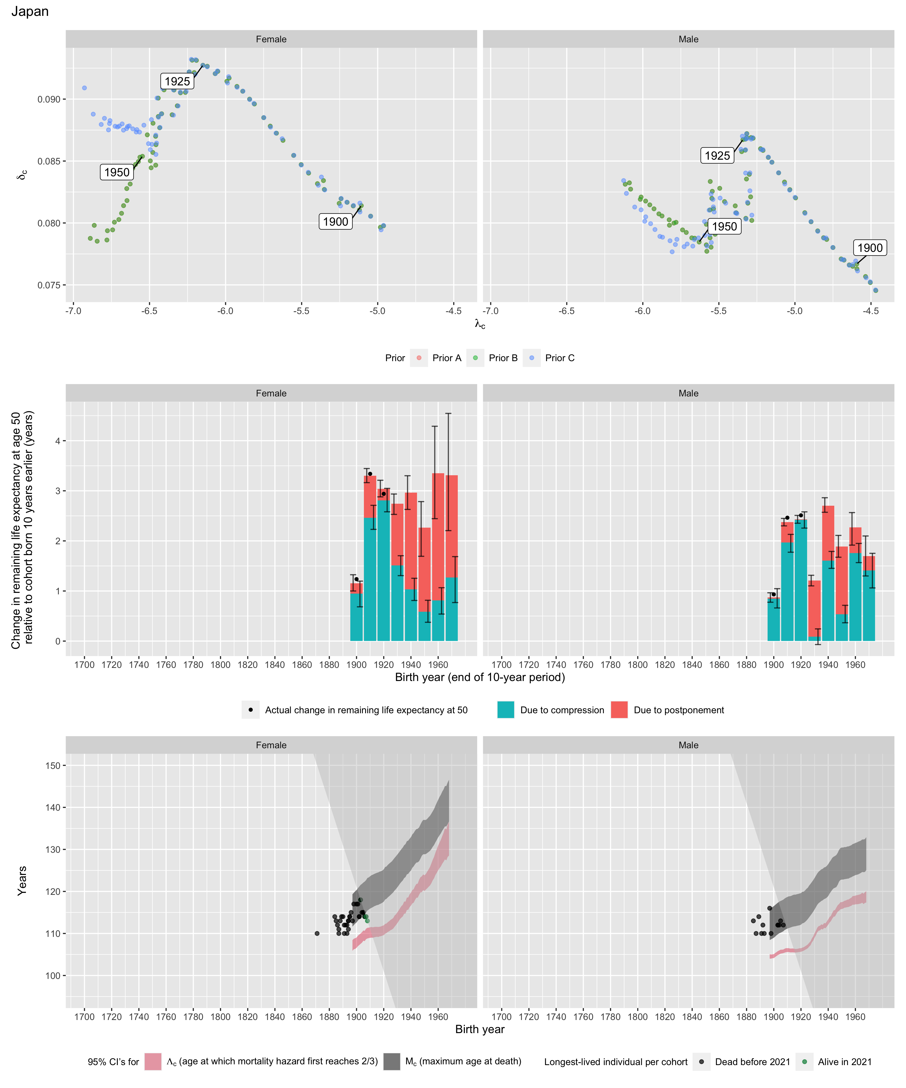
Longest-lived person in each cohort
Sex | Age | Cohort | Alive | Name | Birth date | Death date | Source
Female | 110 | 1871 | N | Oto Michii | 1871-07-17 | 1982-01-10 | GRG
Female | 110 | 1887 | N | data withheld by IDL | 1887-01-09 | 1997-01-09 | GRG
Female | 110 | 1891 | N | data withheld by IDL | 1891-07-04 | 2001-08-28 | GRG
Female | 110 | 1893 | N | data withheld by IDL | 1893-01-03 | 2003-01-06 | GRG
Female | 113 | 1894 | N | Tsuneyo Toyonaga | 1894-05-21 | 2008-02-22 | GRG
Female | 113 | 1894 | N | Kaku Yamanaka | 1894-12-11 | 2008-04-05 | GRG
Female | 114 | 1895 | N | Kama Chinen | 1895-05-10 | 2010-05-02 | GRG
Female | 114 | 1895 | N | Chiyo Shiraishi | 1895-08-06 | 2009-11-19 | GRG
Female | 115 | 1896 | N | Chiyono Hasegawa | 1896-11-20 | 2011-12-02 | GRG
Female | 113 | 1897 | N | Komiya Miyazaki | 1897-08-20 | 2011-01-04 | GRG
Female | 117 | 1898 | N | Misao Okawa | 1898-03-05 | 2015-04-01 | GRG
Female | 117 | 1900 | N | Nabi Tajima | 1900-08-04 | 2018-04-21 | GRG
Female | 117 | 1901 | N | Chiyo Miyako | 1901-05-02 | 2018-07-22 | GRG
Female | 114 | 1902 | N | Mitsue Toyoda | 1902-02-15 | 2016-08-25 | GRG
Female | 114 | 1902 | N | Yukie Hino | 1902-04-17 | 2017-01-13 | GRG
Female | 118 | 1903 | Y | data withheld by IDL |  |  | IDL
Female | 118 | 1903 | N | data withheld by IDL |  |  | IDL
Female | 115 | 1904 | N | Shin Matsushita | 1904-03-30 | 2019-08-27 | GRG
Female | 115 | 1905 | N | Mina Kitagawa | 1905-11-03 | 2020-12-19 | GRG
Female | 115 | 1905 | N | Shigeyo Nakachi | 1905-02-01 | 2021-01-11 | GRG
Female | 114 | 1906 | Y | data withheld by IDL |  |  | IDL
Female | 114 | 1906 | N | data withheld by IDL |  |  | IDL
Female | 114 | 1907 | N | Hama Yasukawa | 1907-01-19 | 2021-05-23 | GRG
Female | 114 | 1907 | N | Yoshi Baba | 1907-06-03 | 2022-01-04 | GRG
Female | 114 | 1907 | Y | data withheld by IDL |  |  | IDL
Female | 113 | 1908 | Y | data withheld by IDL |  |  | IDL
Male | 116 | 1897 | N | Jiroemon Kimura | 1897-04-19 | 2013-06-12 | GRG
Male | 110 | 1898 | N | Takashi Hattori | 1898-03-12 | 2009-01-12 | GRG
Male | 112 | 1903 | N | Sakari Momoi | 1903-02-05 | 2015-07-05 | GRG
Male | 112 | 1903 | N | Yasutaro Koide | 1903-03-13 | 2016-01-19 | GRG
Male | 112 | 1904 | N | Masamitsu Yoshida | 1904-05-30 | 2016-10-29 | GRG
Male | 113 | 1905 | N | Masazou Nonaka | 1905-07-25 | 2019-01-20 | GRG
Male | 112 | 1907 | N | Chitetsu Watanabe | 1907-03-05 | 2020-02-23 | GRG
Female | 114 | 1884 | N | data withheld by IDL |  |  | IDL
Female | 113 | 1885 | N | data withheld by IDL |  |  | IDL
Female | 112 | 1886 | N | data withheld by IDL |  |  | IDL
Female | 111 | 1887 | N | data withheld by IDL |  |  | IDL
Female | 113 | 1888 | N | data withheld by IDL |  |  | IDL
Female | 114 | 1889 | N | data withheld by IDL |  |  | IDL
Female | 114 | 1890 | N | data withheld by IDL |  |  | IDL
Female | 112 | 1891 | N | data withheld by IDL |  |  | IDL
Female | 112 | 1892 | N | data withheld by IDL |  |  | IDL
Female | 112 | 1893 | N | data withheld by IDL |  |  | IDL
Female | 111 | 1894 | N | data withheld by IDL |  |  | IDL
Male | 113 | 1885 | N | data withheld by IDL |  |  | IDL
Male | 110 | 1887 | N | data withheld by IDL |  |  | IDL
Male | 114 | 1889 | N | data withheld by IDL |  |  | IDL
Male | 110 | 1891 | N | data withheld by IDL |  |  | IDL
Male | 112 | 1892 | N | data withheld by IDL |  |  | IDL
Male | 110 | 1893 | N | data withheld by IDL |  |  | IDL

