95% CI’s for Gamma (age at which mortality hazard first reaches 2/3)
and M (maximum age at death)
 | Male |  |  |  | Female
 | Gamma |  | M |  | Gamma |  | M
Cohort | Lower 95% CI | Upper 95% CI | Lower 95% CI | Upper 95% CI | Lower 95% CI | Upper 95% CI | Lower 95% CI | Upper 95% CI
1810 | 99.3 | 101.2 | 100.1 | 107.0 | 98.6 | 100.1 | 99.6 | 107.0
1820 | 99.1 | 101.0 | 100.2 | 107.5 | 98.6 | 100.1 | 100.1 | 107.6
1830 | 99.3 | 100.9 | 100.4 | 107.8 | 98.4 | 99.8 | 100.3 | 107.9
1840 | 99.7 | 101.3 | 101.0 | 108.6 | 98.8 | 100.2 | 101.1 | 108.6
1850 | 98.9 | 100.2 | 100.8 | 108.3 | 98.4 | 99.6 | 101.0 | 108.6
1860 | 99.0 | 100.4 | 101.4 | 109.0 | 99.2 | 100.5 | 101.9 | 109.4
1870 | 99.8 | 101.1 | 102.6 | 110.1 | 100.8 | 102.2 | 103.5 | 111.0
1880 | 100.9 | 102.3 | 104.1 | 111.6 | 102.3 | 103.7 | 105.4 | 112.9
1890 | 101.5 | 102.6 | 104.8 | 112.3 | 103.6 | 104.9 | 107.2 | 114.8
1900 | 100.4 | 101.6 | 104.3 | 111.9 | 102.9 | 104.2 | 107.8 | 115.3
1910 | 101.0 | 102.2 | 104.9 | 112.4 | 103.2 | 104.3 | 108.6 | 116.1
1920 | 102.7 | 103.8 | 106.4 | 113.9 | 104.0 | 105.1 | 109.4 | 116.9
1930 | 106.2 | 108.0 | 109.9 | 117.6 | 107.6 | 109.6 | 112.8 | 120.4
1940 | 111.4 | 114.5 | 115.1 | 123.0 | 113.4 | 116.5 | 118.0 | 125.8
1950 | 112.3 | 117.2 | 117.2 | 125.5 | 114.2 | 117.8 | 119.3 | 127.4
1960 | 107.7 | 113.5 | 114.1 | 122.9 | 110.6 | 115.6 | 117.1 | 125.7
1970 | 104.9 | 111.9 | 112.4 | 121.7 | 107.6 | 114.5 | 115.4 | 124.8
95% CI’s for the change in remaining life expectancy at age 50
relative to cohort born 10 years earlier (years)
 | Due to postponement |  |  |  |  |  | Due to compression
 | Male |  |  | Female |  |  | Male |  |  | Female
Cohort | Lower 95% CI | Median | Upper 95% CI | Lower 95% CI | Median | Upper 95% CI | Lower 95% CI | Median | Upper 95% CI | Lower 95% CI | Median | Upper 95% CI
1810 | -0.4 | -0.1 | 0.2 | -0.3 | -0.0 | 0.3 | 0.4 | 0.8 | 1.3 | 0.2 | 0.6 | 1.1
1820 | -0.3 | -0.0 | 0.2 | -0.2 | -0.0 | 0.2 | 0.4 | 0.7 | 1.1 | 0.4 | 0.7 | 1.1
1830 | -0.3 | -0.0 | 0.3 | -0.3 | -0.1 | 0.2 | 0.2 | 0.6 | 1.0 | 0.4 | 0.7 | 1.1
1840 | 0.5 | 0.1 | 1.0 | 0.4 | 0.1 | 0.8 | 0.3 | 0.6 | 1.0 | 0.1 | 0.5 | 0.9
1850 | -0.5 | -0.2 | 0.0 | -0.4 | -0.2 | 0.1 | 0.7 | 1.0 | 1.3 | 0.3 | 0.6 | 0.9
1860 | 0.5 | 0.1 | 1.1 | 0.4 | 0.2 | 0.8 | 0.4 | 0.7 | 1.1 | 0.1 | 0.4 | 0.7
1870 | 0.8 | 0.2 | 1.3 | 0.6 | 0.5 | 1.1 | 0.5 | 0.8 | 1.2 | 0.0 | 0.4 | 0.7
1880 | 0.8 | 0.3 | 1.3 | 1.1 | 0.4 | 1.6 | 0.4 | 0.7 | 1.0 | 0.7 | 0.9 | 1.2
1890 | 0.1 | 0.2 | 0.6 | 1.6 | 0.4 | 2.2 | -0.1 | 0.2 | 0.5 | 1.1 | 1.5 | 1.8
1900 | -0.6 | -0.3 | -0.1 | -0.5 | -0.2 | 0.0 | -0.1 | 0.2 | 0.5 | 1.8 | 2.1 | 2.4
1910 | -0.1 | 0.2 | 0.4 | 1.0 | 0.1 | 1.5 | -0.6 | -0.3 | -0.1 | 0.9 | 1.2 | 1.4
1920 | 0.6 | 0.5 | 1.1 | 0.5 | 0.3 | 1.0 | 0.1 | 0.4 | 0.7 | 0.2 | 0.4 | 0.7
1930 | 1.7 | 1.2 | 2.3 | 1.3 | 1.6 | 2.0 | 0.4 | 0.7 | 1.1 | -0.4 | -0.1 | 0.2
1940 | 3.0 | 1.9 | 4.1 | 2.1 | 2.5 | 3.4 | 1.3 | 1.7 | 2.1 | -0.1 | 0.3 | 0.7
1950 | 1.0 | 0.6 | 3.2 | -0.3 | 0.5 | 1.5 | 0.9 | 1.4 | 1.9 | -0.1 | 0.2 | 0.7
1960 | -2.9 | -1.7 | -0.4 | -2.5 | -1.2 | 0.0 | 1.3 | 1.8 | 2.3 | 0.7 | 1.2 | 1.5
1970 | -2.1 | -0.9 | 0.5 | -2.3 | -0.9 | 0.4 | 0.5 | 1.0 | 1.6 | 0.7 | 1.3 | 1.9
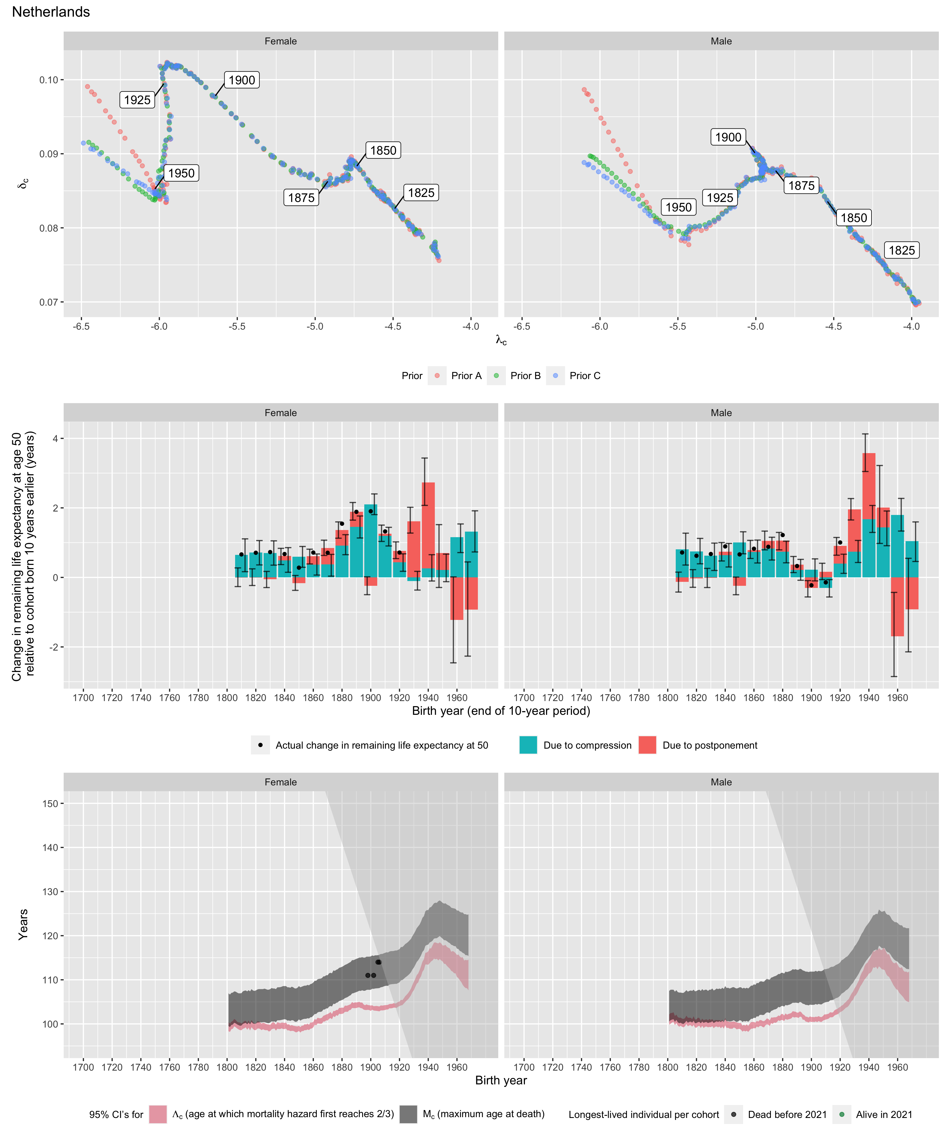
Longest-lived person in each cohort
Sex | Age | Cohort | Alive | Name | Birth date | Death date | Source
Female | 111 | 1898 | N | Catharina Peters-Keultjes | 1898-03-14 | 2009-03-20 | GRG
Female | 111 | 1902 | N | Egbertje Leutscher-de Vries | 1902-10-22 | 2014-08-14 | GRG
Female | 114 | 1905 | N | Geertje Kuijntjes | 1905-07-19 | 2019-12-24 | GRG
Female | 114 | 1906 | N | Anne Brasz-Later | 1906-07-16 | 2020-09-02 | GRG

