95% CI’s for Gamma (age at which mortality hazard first reaches 2/3)
and M (maximum age at death)
 | Male |  |  |  | Female
 | Gamma |  | M |  | Gamma |  | M
Cohort | Lower 95% CI | Upper 95% CI | Lower 95% CI | Upper 95% CI | Lower 95% CI | Upper 95% CI | Lower 95% CI | Upper 95% CI
1900 | 100.0 | 101.0 | 102.7 | 110.2 | 101.5 | 102.7 | 105.9 | 113.5
1910 | 102.5 | 103.4 | 104.9 | 112.4 | 103.3 | 104.6 | 107.9 | 115.4
1920 | 104.9 | 106.0 | 106.6 | 114.1 | 104.9 | 106.3 | 109.2 | 116.8
1930 | 110.7 | 112.3 | 112.0 | 119.5 | 108.8 | 110.6 | 112.9 | 120.5
1940 | 117.2 | 119.8 | 118.7 | 126.3 | 114.4 | 116.7 | 118.3 | 126.0
1950 | 117.8 | 121.5 | 119.4 | 127.4 | 112.2 | 115.3 | 116.8 | 124.7
1960 | 118.2 | 124.0 | 121.0 | 129.8 | 112.2 | 117.5 | 117.8 | 126.5
1970 | 117.3 | 124.9 | 121.3 | 131.0 | 113.4 | 120.2 | 119.3 | 128.7
95% CI’s for the change in remaining life expectancy at age 50
relative to cohort born 10 years earlier (years)
 | Due to postponement |  |  |  |  |  | Due to compression
 | Male |  |  | Female |  |  | Male |  |  | Female
Cohort | Lower 95% CI | Median | Upper 95% CI | Lower 95% CI | Median | Upper 95% CI | Lower 95% CI | Median | Upper 95% CI | Lower 95% CI | Median | Upper 95% CI
1900 | -0.1 | 0.1 | 0.3 | 0.2 | 0.1 | 0.6 | -0.3 | 0.0 | 0.3 | 0.0 | 0.3 | 0.6
1910 | 1.6 | 0.7 | 1.9 | 1.6 | 0.7 | 1.9 | 0.8 | 1.1 | 1.3 | 0.9 | 1.1 | 1.3
1920 | 1.3 | 0.7 | 1.6 | 1.4 | 0.6 | 1.8 | 0.5 | 0.7 | 1.0 | 0.7 | 1.0 | 1.2
1930 | 1.8 | 1.7 | 2.2 | 2.5 | 1.6 | 3.0 | 0.1 | 0.3 | 0.6 | 0.9 | 1.1 | 1.4
1940 | 3.6 | 2.0 | 4.4 | 2.8 | 2.3 | 3.6 | 1.6 | 1.9 | 2.3 | 0.6 | 0.9 | 1.1
1950 | 0.8 | 0.3 | 2.1 | -1.4 | -0.7 | -0.1 | 0.7 | 1.1 | 1.4 | 0.4 | 0.7 | 1.0
1960 | 1.7 | 0.4 | 3.4 | 0.7 | 0.4 | 2.6 | 1.7 | 2.1 | 2.5 | 0.9 | 1.2 | 1.6
1970 | 1.0 | 0.0 | 3.0 | 0.8 | 0.7 | 2.9 | 1.3 | 1.9 | 2.5 | 0.6 | 1.1 | 1.6
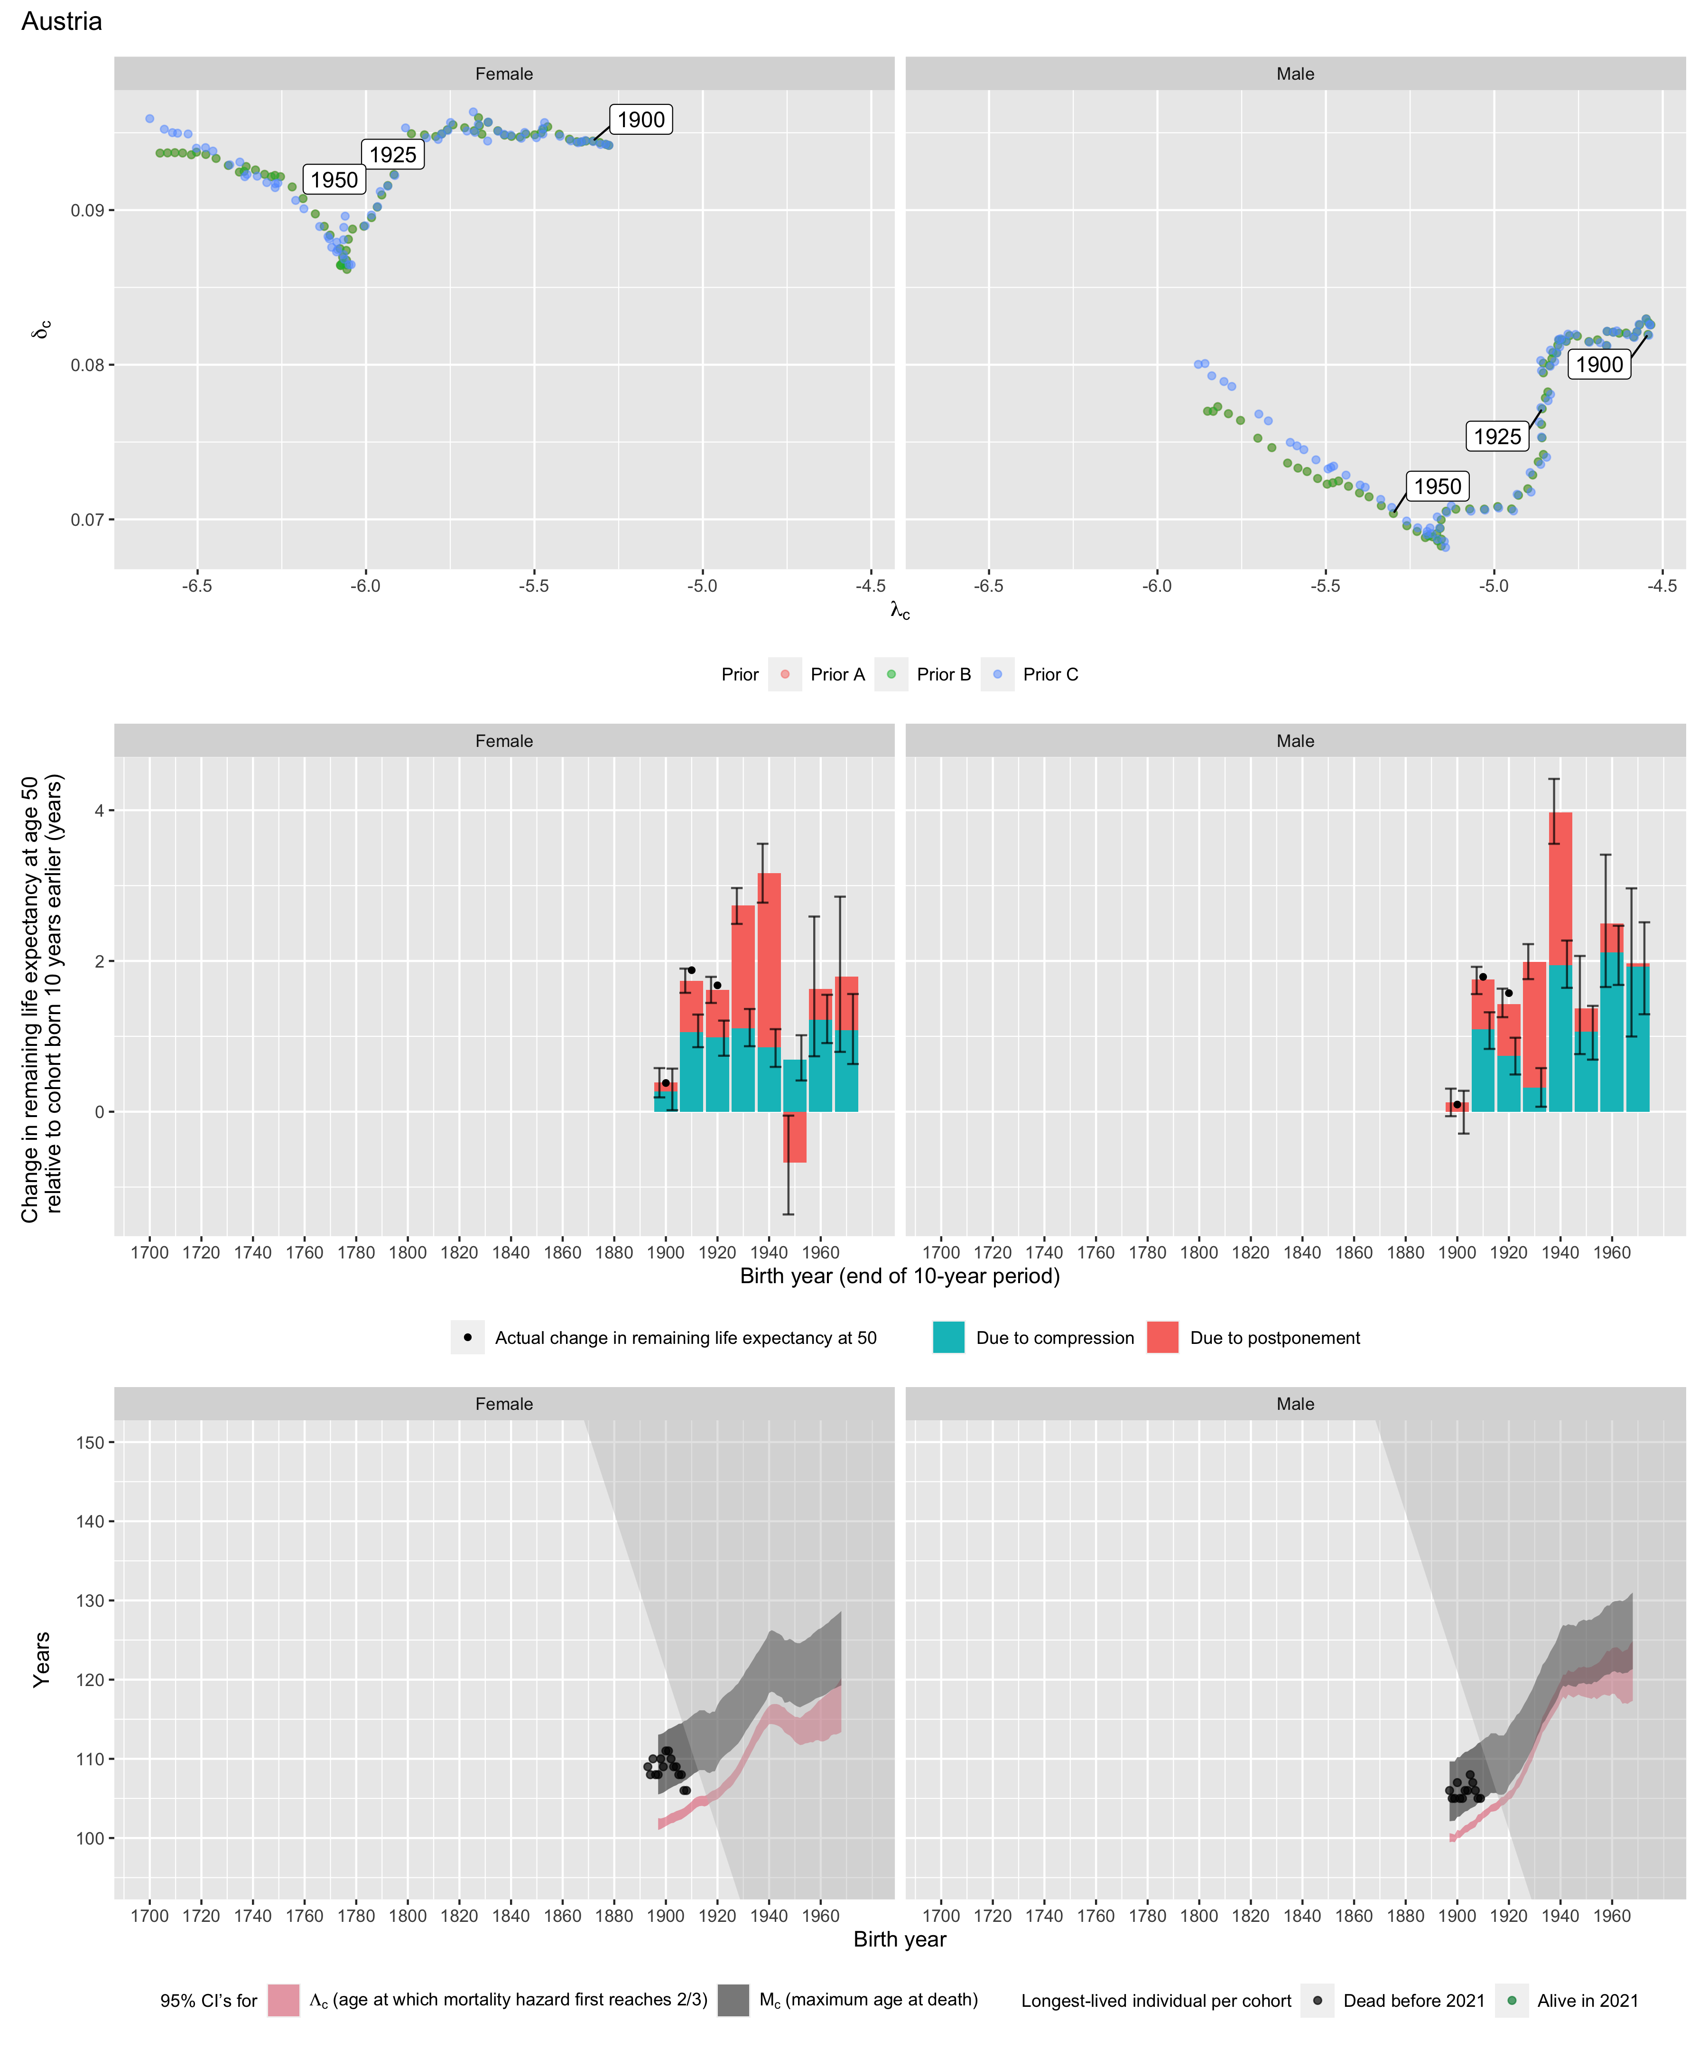
Longest-lived person in each cohort
Sex | Age | Cohort | Alive | Name | Birth date | Death date | Source
Female | 109 | 1893 | N | data withheld by IDL |  |  | IDL
Female | 108 | 1894 | N | data withheld by IDL |  |  | IDL
Female | 110 | 1895 | N | data withheld by IDL |  |  | IDL
Female | 108 | 1896 | N | data withheld by IDL |  |  | IDL
Female | 108 | 1897 | N | data withheld by IDL |  |  | IDL
Female | 110 | 1898 | N | data withheld by IDL |  |  | IDL
Female | 109 | 1899 | N | data withheld by IDL |  |  | IDL
Female | 111 | 1900 | N | data withheld by IDL |  |  | IDL
Female | 111 | 1901 | N | data withheld by IDL |  |  | IDL
Female | 110 | 1902 | N | data withheld by IDL |  |  | IDL
Female | 109 | 1903 | N | data withheld by IDL |  |  | IDL
Female | 109 | 1904 | N | data withheld by IDL |  |  | IDL
Female | 108 | 1905 | N | data withheld by IDL |  |  | IDL
Female | 108 | 1906 | N | data withheld by IDL |  |  | IDL
Female | 106 | 1907 | N | data withheld by IDL |  |  | IDL
Female | 106 | 1908 | N | data withheld by IDL |  |  | IDL
Male | 106 | 1897 | N | data withheld by IDL |  |  | IDL
Male | 105 | 1898 | N | data withheld by IDL |  |  | IDL
Male | 105 | 1899 | N | data withheld by IDL |  |  | IDL
Male | 107 | 1900 | N | data withheld by IDL |  |  | IDL
Male | 105 | 1901 | N | data withheld by IDL |  |  | IDL
Male | 105 | 1902 | N | data withheld by IDL |  |  | IDL
Male | 106 | 1903 | N | data withheld by IDL |  |  | IDL
Male | 106 | 1904 | N | data withheld by IDL |  |  | IDL
Male | 108 | 1905 | N | data withheld by IDL |  |  | IDL
Male | 107 | 1906 | N | data withheld by IDL |  |  | IDL
Male | 106 | 1907 | N | data withheld by IDL |  |  | IDL
Male | 105 | 1908 | N | data withheld by IDL |  |  | IDL
Male | 105 | 1909 | N | data withheld by IDL |  |  | IDL

