95% CI’s for Gamma (age at which mortality hazard first reaches 2/3)
and M (maximum age at death)
 | Male |  |  |  | Female
 | Gamma |  | M |  | Gamma |  | M
Cohort | Lower 95% CI | Upper 95% CI | Lower 95% CI | Upper 95% CI | Lower 95% CI | Upper 95% CI | Lower 95% CI | Upper 95% CI
1800 | 99.9 | 101.8 | 100.6 | 107.4 | 100.1 | 101.8 | 100.9 | 107.9
1810 | 101.5 | 103.5 | 102.1 | 108.7 | 102.4 | 104.6 | 103.1 | 109.8
1820 | 101.3 | 103.1 | 102.0 | 108.8 | 101.6 | 103.2 | 102.4 | 109.5
1830 | 100.5 | 102.2 | 101.3 | 108.4 | 101.3 | 103.2 | 102.3 | 109.6
1840 | 101.0 | 102.8 | 101.7 | 108.7 | 101.5 | 103.2 | 102.4 | 109.6
1850 | 100.8 | 102.4 | 101.8 | 109.0 | 101.2 | 102.8 | 102.4 | 109.9
1860 | 102.1 | 103.7 | 102.9 | 110.1 | 102.2 | 103.6 | 103.4 | 110.8
1870 | 101.7 | 103.3 | 102.9 | 110.2 | 102.0 | 103.5 | 103.5 | 111.0
1880 | 100.5 | 101.9 | 102.4 | 109.9 | 101.7 | 103.2 | 104.0 | 111.6
1890 | 99.8 | 101.1 | 102.2 | 109.7 | 102.4 | 103.7 | 105.1 | 112.7
1900 | 99.9 | 101.0 | 102.6 | 110.1 | 102.4 | 103.7 | 106.0 | 113.6
1910 | 101.1 | 102.3 | 103.7 | 111.3 | 103.1 | 104.2 | 107.0 | 114.6
1920 | 103.2 | 104.4 | 105.5 | 112.9 | 104.7 | 105.8 | 108.5 | 116.0
1930 | 107.8 | 109.7 | 109.4 | 116.9 | 108.1 | 109.8 | 111.3 | 119.0
1940 | 110.5 | 113.9 | 112.7 | 120.6 | 112.8 | 115.5 | 115.5 | 123.3
1950 | 113.1 | 118.4 | 116.2 | 124.8 | 113.5 | 117.3 | 117.1 | 125.3
1960 | 108.9 | 116.0 | 113.8 | 123.2 | 111.4 | 116.2 | 116.1 | 124.6
1970 | 105.4 | 115.3 | 111.5 | 122.2 | 109.1 | 115.5 | 114.9 | 124.0
95% CI’s for the change in remaining life expectancy at age 50
relative to cohort born 10 years earlier (years)
 | Due to postponement |  |  |  |  |  | Due to compression
 | Male |  |  | Female |  |  | Male |  |  | Female
Cohort | Lower 95% CI | Median | Upper 95% CI | Lower 95% CI | Median | Upper 95% CI | Lower 95% CI | Median | Upper 95% CI | Lower 95% CI | Median | Upper 95% CI
1800 | -0.7 | -0.4 | -0.1 | -0.7 | -0.4 | -0.1 | 0.3 | 0.8 | 1.4 | 0.4 | 0.8 | 1.3
1810 | 0.2 | 0.4 | 0.8 | 0.4 | 0.6 | 0.9 | -0.3 | 0.2 | 0.6 | -0.8 | -0.4 | 0.0
1820 | -0.4 | -0.1 | 0.2 | -0.6 | -0.3 | -0.0 | -0.0 | 0.4 | 0.9 | 0.5 | 1.0 | 1.5
1830 | -0.5 | -0.2 | 0.0 | -0.3 | -0.0 | 0.2 | -0.1 | 0.3 | 0.8 | -0.5 | -0.1 | 0.4
1840 | 0.1 | 0.1 | 0.6 | 0.3 | 0.0 | 0.7 | -0.2 | 0.2 | 0.6 | 0.0 | 0.5 | 0.8
1850 | -0.4 | -0.1 | 0.2 | -0.3 | -0.1 | 0.1 | 0.5 | 0.9 | 1.3 | 0.2 | 0.6 | 1.0
1860 | 0.1 | 0.3 | 0.6 | 0.3 | 0.2 | 0.8 | -0.5 | -0.1 | 0.3 | -0.1 | 0.3 | 0.6
1870 | -0.4 | -0.1 | 0.2 | -0.3 | -0.0 | 0.2 | 0.8 | 1.2 | 1.6 | 0.6 | 1.0 | 1.4
1880 | -0.7 | -0.4 | -0.1 | -0.3 | -0.1 | 0.1 | 0.5 | 0.9 | 1.3 | 0.6 | 1.0 | 1.4
1890 | -0.5 | -0.2 | 0.0 | 1.1 | 0.2 | 1.5 | 0.0 | 0.4 | 0.8 | 0.7 | 1.1 | 1.5
1900 | -0.4 | -0.0 | 0.1 | 1.2 | 0.0 | 1.7 | -0.5 | -0.2 | 0.2 | 1.1 | 1.4 | 1.7
1910 | 0.2 | 0.4 | 0.6 | 1.0 | 0.2 | 1.5 | -0.5 | -0.1 | 0.2 | 0.8 | 1.0 | 1.4
1920 | 0.6 | 0.7 | 1.0 | 0.8 | 0.7 | 1.2 | -0.2 | 0.1 | 0.4 | 0.0 | 0.3 | 0.7
1930 | 1.8 | 1.5 | 2.4 | 1.4 | 1.5 | 1.9 | 0.3 | 0.6 | 0.9 | -0.2 | 0.1 | 0.4
1940 | 2.7 | 1.2 | 3.9 | 2.0 | 2.1 | 3.0 | 1.7 | 2.1 | 2.6 | -0.0 | 0.4 | 0.7
1950 | 1.6 | 1.3 | 3.7 | 0.4 | 0.5 | 2.0 | 0.7 | 1.3 | 1.8 | 0.3 | 0.7 | 1.2
1960 | -3.0 | -1.3 | 0.3 | -1.9 | -0.7 | 0.4 | 1.6 | 2.1 | 2.8 | 1.1 | 1.6 | 2.1
1970 | -2.9 | -1.2 | 0.7 | -2.1 | -0.9 | 0.4 | 0.6 | 1.4 | 2.3 | 0.5 | 1.4 | 2.2
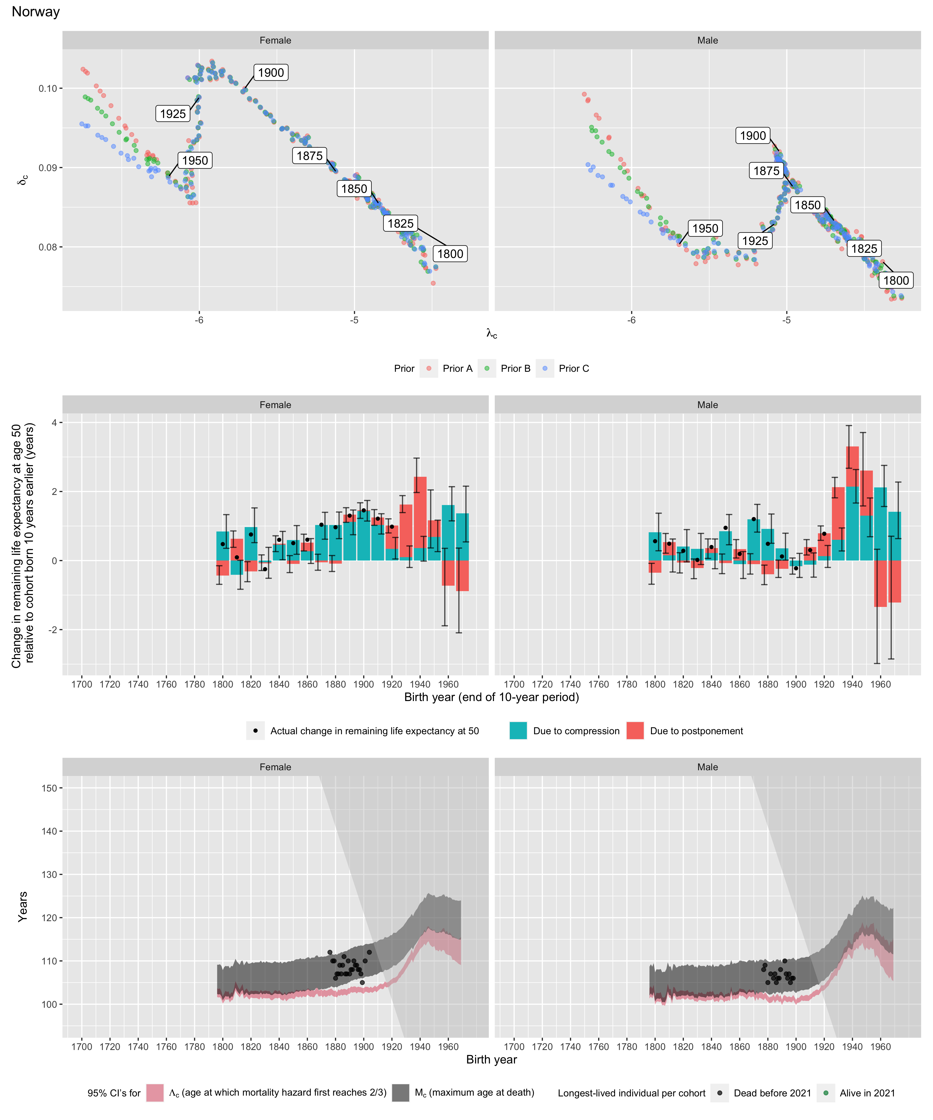
Longest-lived person in each cohort
Sex | Age | Cohort | Alive | Name | Birth date | Death date | Source
Female | 112 | 1876 | N | data withheld by IDL |  |  | IDL
Female | 110 | 1878 | N | data withheld by IDL |  |  | IDL
Female | 110 | 1879 | N | data withheld by IDL |  |  | IDL
Female | 106 | 1880 | N | data withheld by IDL |  |  | IDL
Female | 107 | 1881 | N | data withheld by IDL |  |  | IDL
Female | 107 | 1882 | N | data withheld by IDL |  |  | IDL
Female | 109 | 1883 | N | data withheld by IDL |  |  | IDL
Female | 107 | 1884 | N | data withheld by IDL |  |  | IDL
Female | 109 | 1885 | N | data withheld by IDL |  |  | IDL
Female | 111 | 1886 | N | data withheld by IDL |  |  | IDL
Female | 107 | 1887 | N | data withheld by IDL |  |  | IDL
Female | 107 | 1888 | N | data withheld by IDL |  |  | IDL
Female | 110 | 1889 | N | data withheld by IDL |  |  | IDL
Female | 107 | 1890 | N | data withheld by IDL |  |  | IDL
Female | 108 | 1891 | N | data withheld by IDL |  |  | IDL
Female | 108 | 1892 | N | data withheld by IDL |  |  | IDL
Female | 110 | 1893 | N | data withheld by IDL |  |  | IDL
Female | 109 | 1894 | N | data withheld by IDL |  |  | IDL
Female | 109 | 1895 | N | data withheld by IDL |  |  | IDL
Female | 108 | 1896 | N | data withheld by IDL |  |  | IDL
Female | 108 | 1897 | N | data withheld by IDL |  |  | IDL
Female | 107 | 1898 | N | data withheld by IDL |  |  | IDL
Female | 105 | 1899 | N | data withheld by IDL |  |  | IDL
Female | 110 | 1901 | N | Helene Andrea Nilsen | 1901-04-07 | 2011-10-31 | GRG
Female | 112 | 1904 | N | Elisabet Ekenaes | 1904-12-26 | 2017-01-04 | GRG
Male | 108 | 1877 | N | data withheld by IDL |  |  | IDL
Male | 109 | 1878 | N | data withheld by IDL |  |  | IDL
Male | 105 | 1880 | N | data withheld by IDL |  |  | IDL
Male | 107 | 1882 | N | data withheld by IDL |  |  | IDL
Male | 106 | 1884 | N | data withheld by IDL |  |  | IDL
Male | 107 | 1885 | N | data withheld by IDL |  |  | IDL
Male | 105 | 1886 | N | data withheld by IDL |  |  | IDL
Male | 106 | 1887 | N | data withheld by IDL |  |  | IDL
Male | 106 | 1888 | N | data withheld by IDL |  |  | IDL
Male | 108 | 1889 | N | data withheld by IDL |  |  | IDL
Male | 110 | 1892 | N | data withheld by IDL |  |  | IDL
Male | 107 | 1893 | N | data withheld by IDL |  |  | IDL
Male | 106 | 1894 | N | data withheld by IDL |  |  | IDL
Male | 107 | 1895 | N | data withheld by IDL |  |  | IDL
Male | 105 | 1896 | N | data withheld by IDL |  |  | IDL
Male | 106 | 1897 | N | data withheld by IDL |  |  | IDL
Male | 106 | 1898 | N | data withheld by IDL |  |  | IDL

