95% CI’s for Gamma (age at which mortality hazard first reaches 2/3)
and M (maximum age at death)
 | Male |  |  |  | Female
 | Gamma |  | M |  | Gamma |  | M
Cohort | Lower 95% CI | Upper 95% CI | Lower 95% CI | Upper 95% CI | Lower 95% CI | Upper 95% CI | Lower 95% CI | Upper 95% CI
1830 | 96.9 | 98.5 | 97.7 | 104.8 | 96.5 | 98.1 | 97.7 | 105.1
1840 | 96.9 | 98.4 | 97.7 | 104.8 | 97.0 | 98.6 | 98.4 | 105.8
1850 | 97.8 | 99.3 | 98.5 | 105.6 | 97.3 | 98.9 | 98.8 | 106.4
1860 | 98.1 | 99.4 | 99.1 | 106.4 | 99.0 | 100.5 | 100.6 | 108.2
1870 | 99.1 | 100.5 | 100.4 | 107.9 | 99.9 | 101.3 | 102.0 | 109.6
1880 | 101.3 | 102.6 | 102.5 | 109.9 | 101.6 | 103.0 | 104.0 | 111.6
1890 | 101.1 | 102.3 | 102.8 | 110.3 | 103.2 | 104.5 | 105.8 | 113.4
1900 | 101.8 | 103.1 | 103.9 | 111.5 | 103.9 | 105.3 | 107.6 | 115.1
1910 | 103.3 | 104.3 | 105.6 | 113.1 | 104.5 | 105.7 | 108.7 | 116.2
1920 | 104.5 | 105.6 | 107.0 | 114.5 | 105.4 | 106.7 | 109.7 | 117.3
1930 | 109.2 | 111.0 | 111.6 | 119.1 | 110.4 | 112.2 | 114.4 | 122.1
1940 | 115.4 | 119.0 | 117.7 | 125.6 | 117.0 | 120.2 | 120.4 | 128.4
1950 | 115.4 | 120.8 | 118.6 | 127.3 | 118.0 | 122.4 | 122.0 | 130.3
1960 | 113.3 | 121.0 | 118.0 | 128.0 | 116.9 | 123.2 | 121.9 | 131.2
1970 | 112.2 | 121.6 | 117.7 | 128.7 | 116.7 | 124.4 | 122.3 | 132.3
95% CI’s for the change in remaining life expectancy at age 50
relative to cohort born 10 years earlier (years)
 | Due to postponement |  |  |  |  |  | Due to compression
 | Male |  |  | Female |  |  | Male |  |  | Female
Cohort | Lower 95% CI | Median | Upper 95% CI | Lower 95% CI | Median | Upper 95% CI | Lower 95% CI | Median | Upper 95% CI | Lower 95% CI | Median | Upper 95% CI
1830 | 0.1 | 0.1 | 0.5 | 0.1 | 0.1 | 0.6 | -0.2 | 0.1 | 0.5 | -0.1 | 0.3 | 0.7
1840 | -0.2 | -0.0 | 0.2 | 0.4 | 0.1 | 0.8 | -0.2 | 0.1 | 0.5 | 0.1 | 0.5 | 0.8
1850 | 0.0 | 0.2 | 0.4 | 0.5 | 0.1 | 1.0 | -0.2 | 0.1 | 0.4 | 0.3 | 0.7 | 1.1
1860 | 1.0 | 0.0 | 1.4 | 1.0 | 0.4 | 1.4 | 0.8 | 1.1 | 1.5 | 0.4 | 0.8 | 1.2
1870 | 1.1 | 0.2 | 1.5 | 1.4 | 0.2 | 1.9 | 0.7 | 1.1 | 1.4 | 1.0 | 1.4 | 1.8
1880 | 0.8 | 0.5 | 1.2 | 1.1 | 0.5 | 1.6 | 0.1 | 0.4 | 0.7 | 0.5 | 0.9 | 1.2
1890 | -0.3 | -0.1 | 0.2 | 1.7 | 0.5 | 2.2 | 1.1 | 1.4 | 1.7 | 1.2 | 1.5 | 1.9
1900 | 0.4 | 0.2 | 0.8 | 1.9 | 0.3 | 2.4 | 0.1 | 0.4 | 0.7 | 1.4 | 1.8 | 2.1
1910 | 1.2 | 0.4 | 1.6 | 1.8 | 0.2 | 2.3 | 0.8 | 1.0 | 1.3 | 1.6 | 1.9 | 2.3
1920 | 1.4 | 0.4 | 1.8 | 1.3 | 0.4 | 1.8 | 0.9 | 1.2 | 1.5 | 0.8 | 1.1 | 1.5
1930 | 2.4 | 1.6 | 2.9 | 2.4 | 2.2 | 3.1 | 0.7 | 1.0 | 1.3 | 0.3 | 0.6 | 0.8
1940 | 3.1 | 2.3 | 4.3 | 2.5 | 3.0 | 3.8 | 1.0 | 1.4 | 1.8 | -0.2 | 0.2 | 0.6
1950 | 0.8 | 0.2 | 2.9 | 0.5 | 0.7 | 2.5 | 1.1 | 1.6 | 2.1 | 0.4 | 0.9 | 1.4
1960 | -1.9 | -0.3 | 1.4 | -1.4 | -0.1 | 1.3 | 1.5 | 1.9 | 2.5 | 0.8 | 1.3 | 1.8
1970 | -1.8 | -0.2 | 1.4 | -0.2 | 0.2 | 2.4 | 0.3 | 1.0 | 1.7 | 0.2 | 0.9 | 1.6
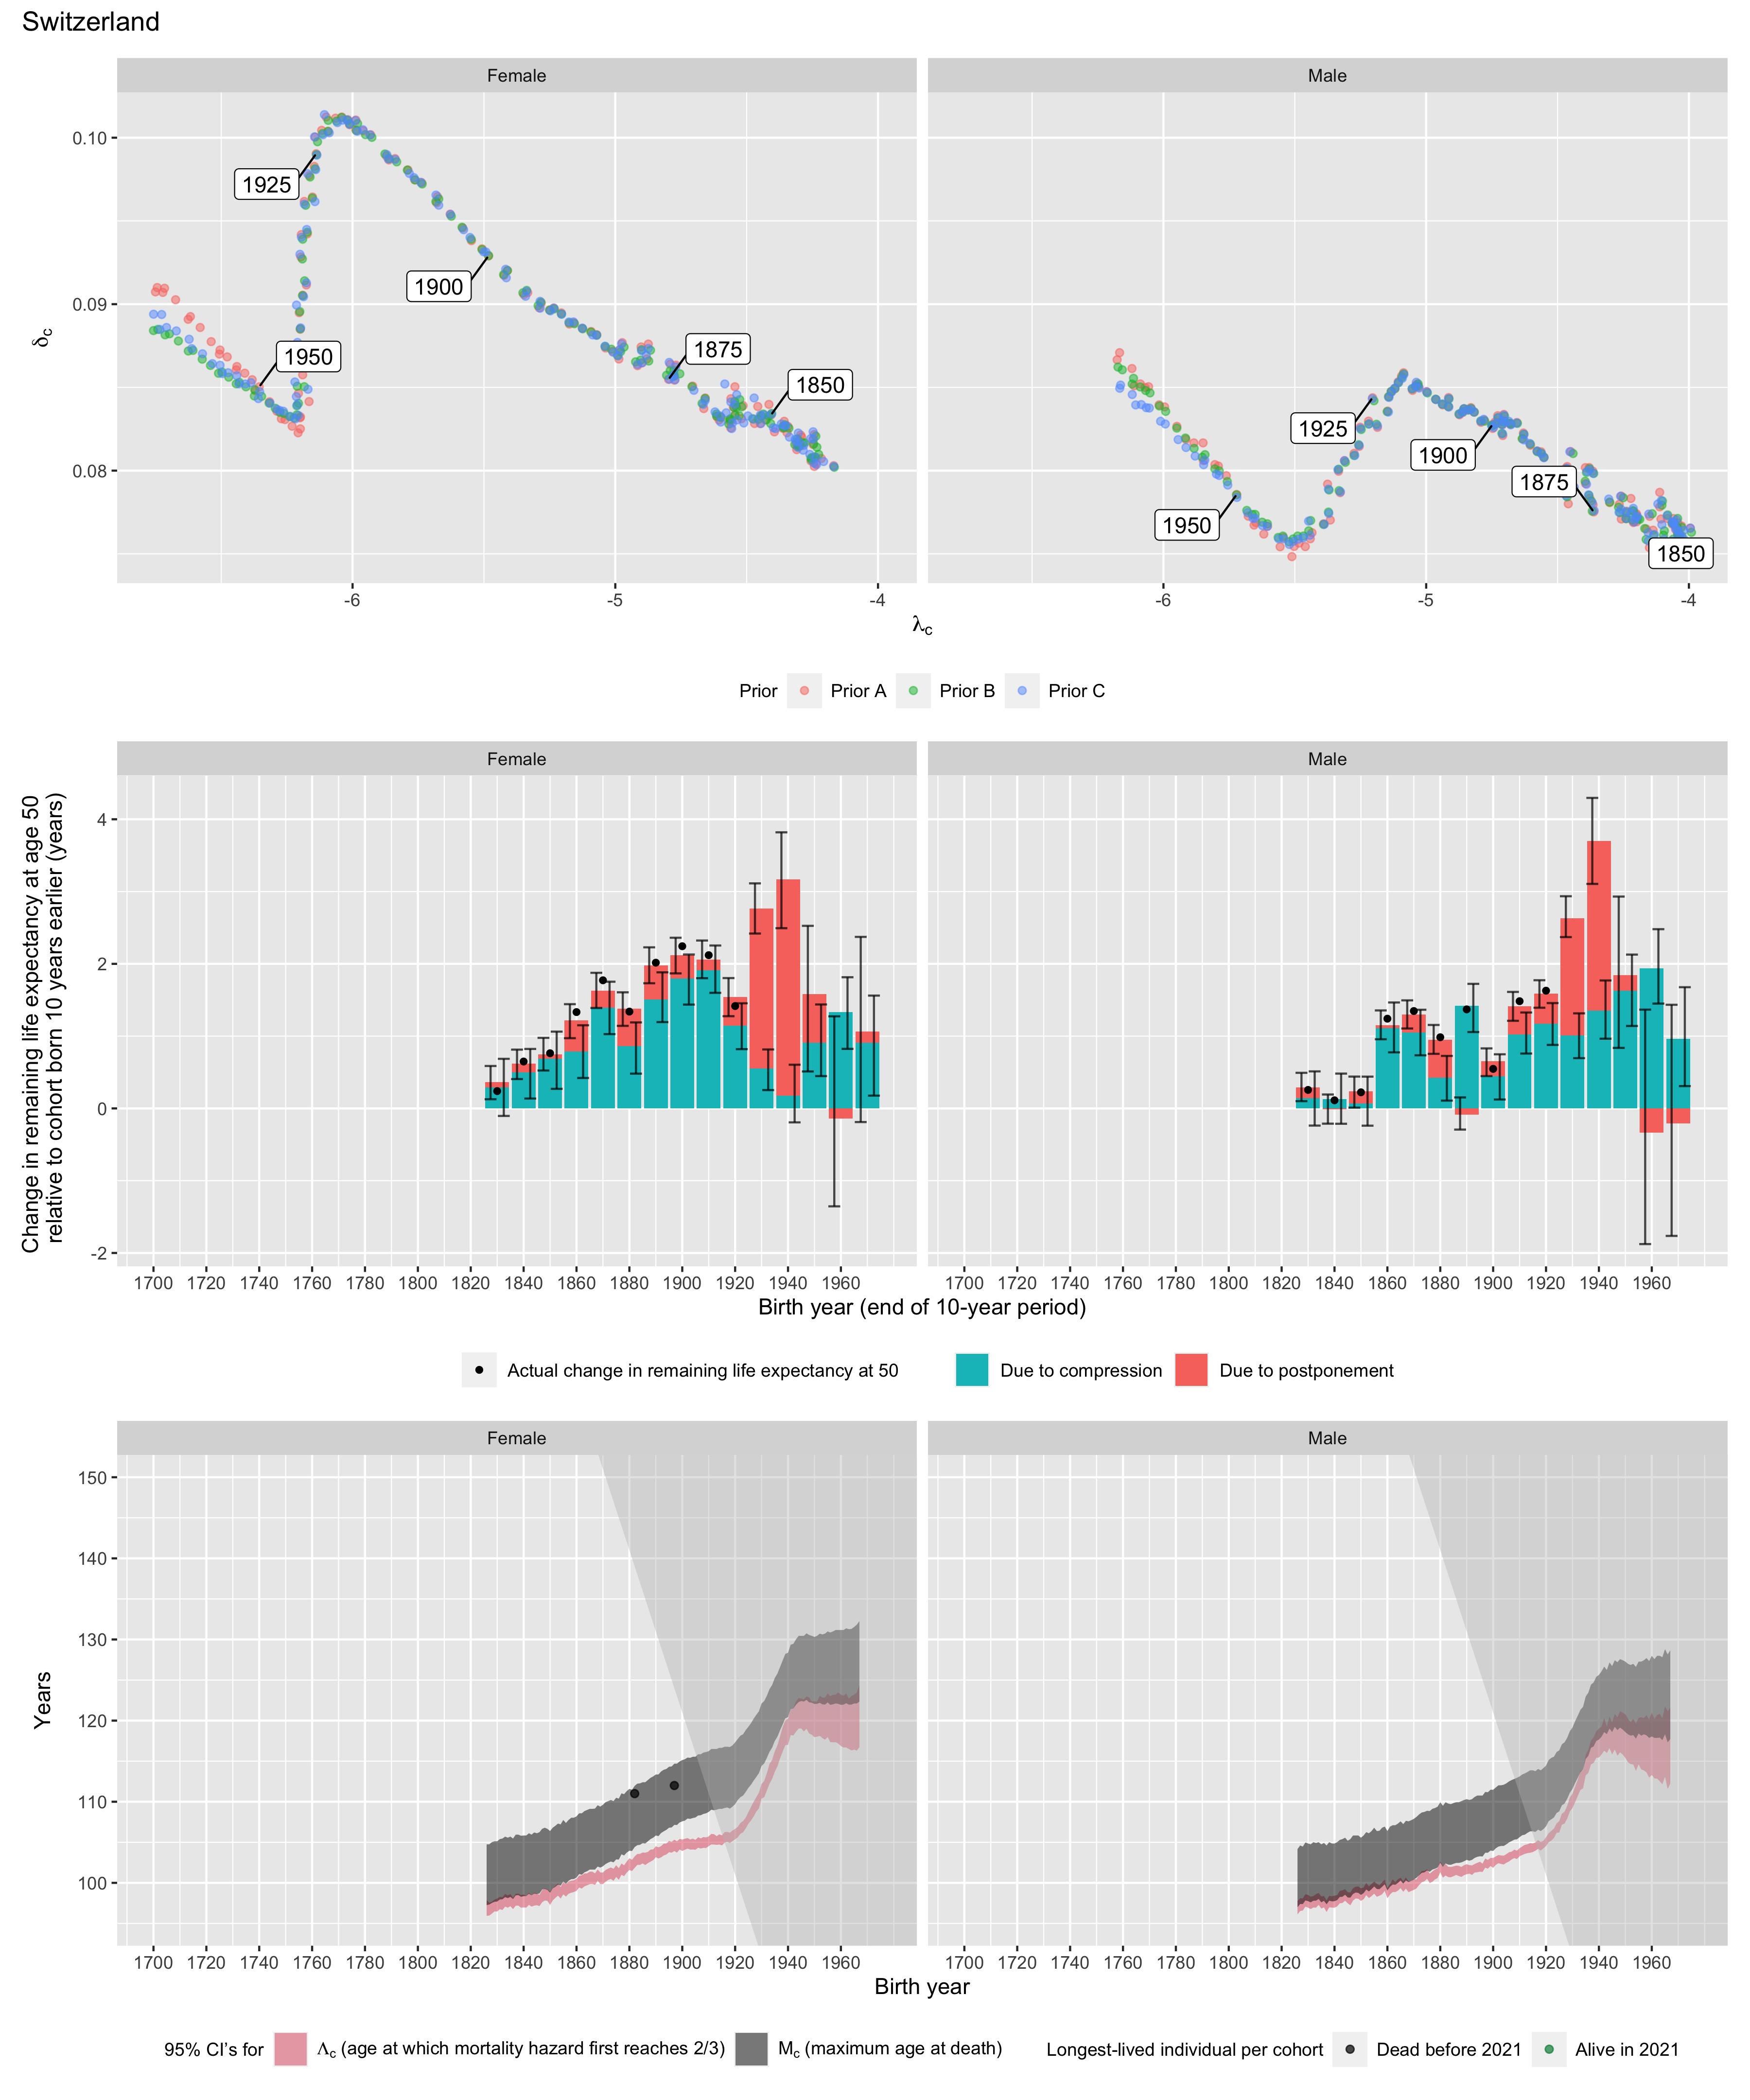
Longest-lived person in each cohort
Sex | Age | Cohort | Alive | Name | Birth date | Death date | Source
Female | 111 | 1882 | N | Andree Fehr-de Boulay | 1882-02-07 | 1993-05-19 | GRG
Female | 112 | 1897 | N | Rosa Rein | 1897-03-24 | 2010-02-14 | GRG

